Go to the following link: https://cshsurrey.healthit.org.uk/patheks
Registering (if this is your first time using the system)
Click on the register button (in red circle)
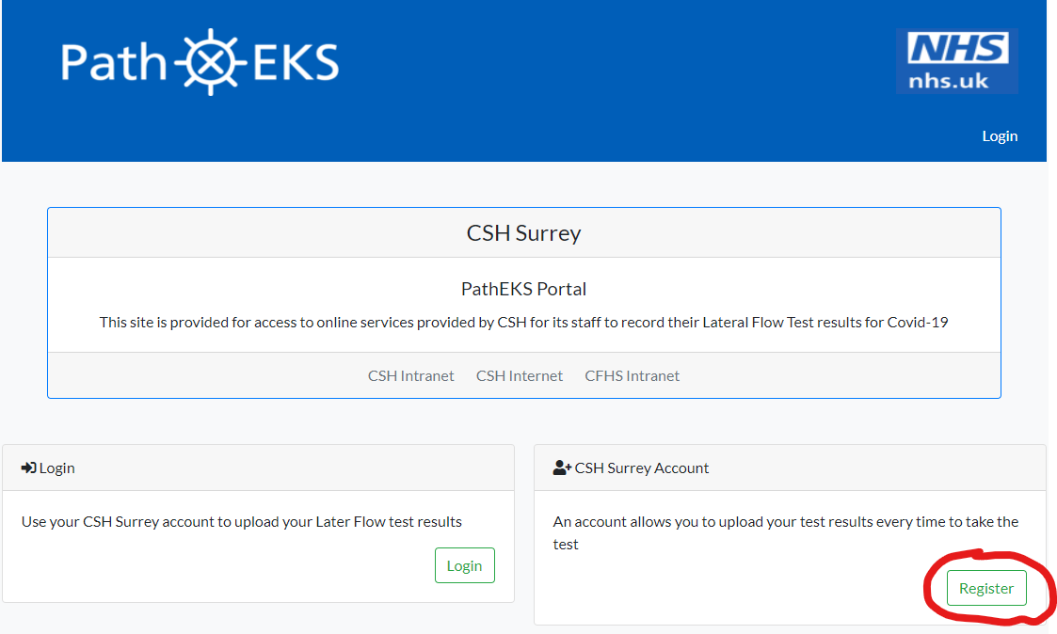

Fill in your details on the registration page, you will be asked for your Name, Date of Birth, Gender, email address (can be work or home), NHS number, a password, Home address, postcode, phone number, if there is anything else we need to know and your consent for your information to be held by us. Only the items above in bold and underlined are mandatory.
Once filled in, click on the green register button at the bottom of the page.

You will need to activate your account. The system will send you a 4 digit code to the email address you used in the previous step. Get your code from the email (the email will come from CSH Surrey) and click on the Activate Account button in the system.
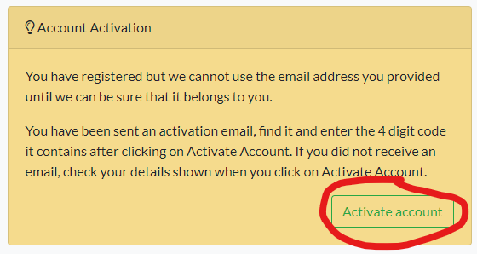

You will be taken to the following screen where you can activate your account by putting the 4 digit code into the box highlighted below and pressing Activate.
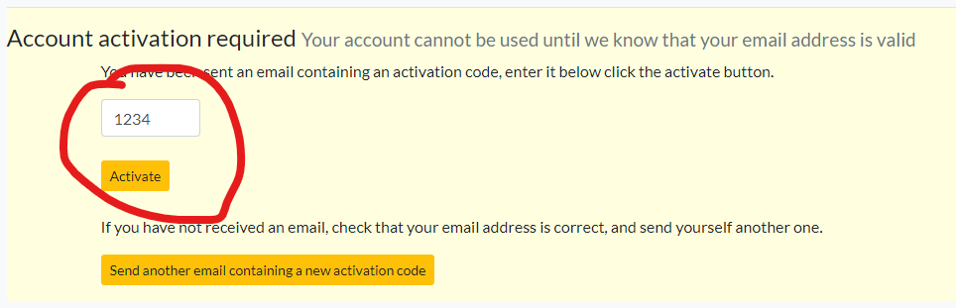

Adding your Lot number (essential step in order to be able to submit test results)

You will be taken to a page which has all of your details you have just entered on it. At the top is a blue link called Health Worker account details. Click on the link (shown below).
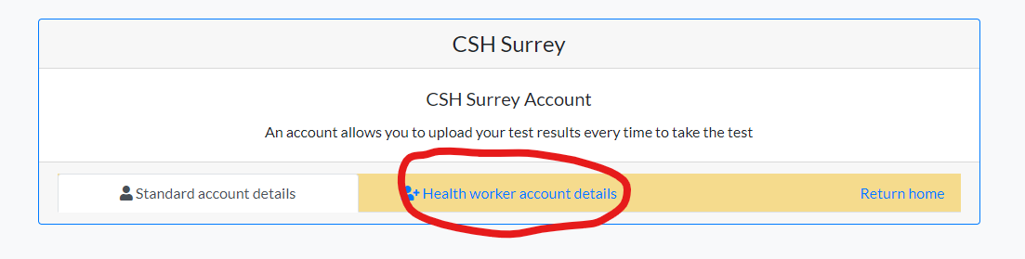

On this new page you will need to enter the following information:

- Employer (should always be CSH)
- Job Title
- Email address of your manager
- Occupation
- Workplace (what service your work in)
- Ethnicity
- Have you tested Covid-19 positive
- Can we contact you about taking part in clinical research trials
- Testing Kit Lot number

You will need to ensure that the Lot number from the side of the box containing your test kit you were given is entered into the Testing Kit Lot number field. Without this you will not be able to submit test results.
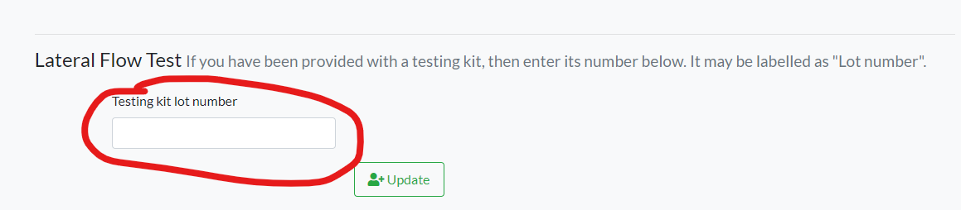

Make sure you click update to keep the changes you have made.

At the top of the page there is a hyperlink to return home. Click this and on the home page you will now see that a green button has appeared which will allow you to submit test results when you take a test.
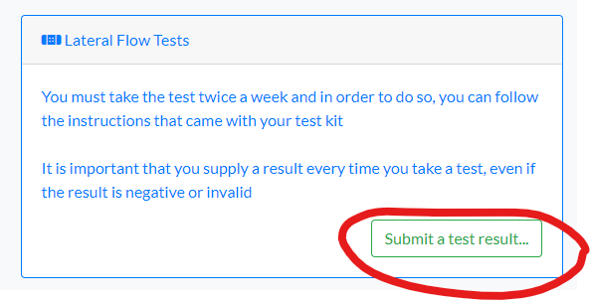
Adding a test result
Log-in to the system using your email address and chosen password (Go to the following link to log-in: https://cshsurrey.healthit.org.uk/patheks)
On the log-in page you will need to click on the Submit a Test Result button …
This will only appear if you have entered the Lot number from the previous step. If you have not please go back to the ‘Adding your Lot number’ section and follow the instructions.

On the next page you will have some information about the test and a ‘Register a new test result’ green button. Click the button.
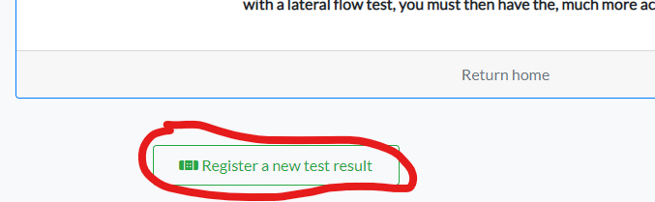

The next page will guide you through entering a test result. You will need to enter the serial number which you can find at the top of the test itself.
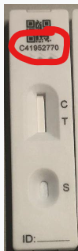

Click the button for whether your test was Negative, Positive, or Invalid. The date and time will auto populate to now, but this can be changed if you are entering a result retrospectively.
Click on the ‘Submit a Test Result’ green button and that is the result entering completed.

Depending on your result you will be given a message to either continue testing as normal (negative or invalid test results) or self-isolate and follow the absence reporting procedure as per CSH HR rules (positive test result)

